Training Report on Paper Packaging and Designing, NIZC Kawajangsa, Thimphu

1. Introduction
As an activity of Products Innovation and Design unit, Agency for Promotion of Indigenous Craft, APIC, has organized 10 days practical based training workshop on paper packaging and designing from 4th– 13th November 2013 at National Institute of Zorig Chusum, Kawang Jangsa with the financial support from UNDP.
The participants were from craft bazaar and National Institute of Zorig Chhusum. We hired two resource people, Mr. Jigme Dorji from Khapti, Trashigang and Mr. Rinchen Phuntsho, Proprietor, Tashi Gongphel and Bhutanese Paper Factory, Paro who have relevant skills for this workshop.
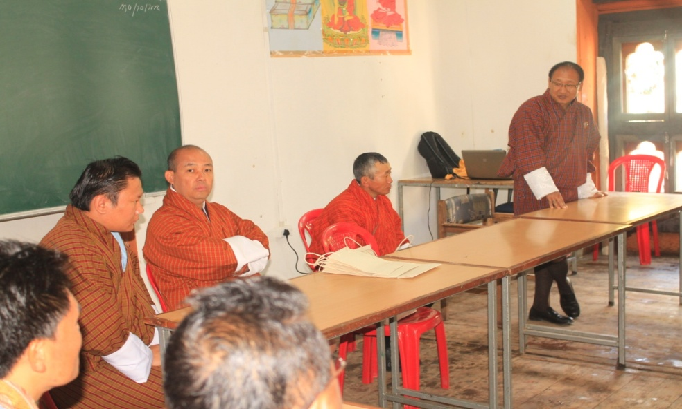
The main reason for organising this workshop is to inculcate skills and give ideas on proper packaging for craft items that are being sold in our local markets. Though the goods are being finely produced and look attractive but it confuses our buyers, especially tourist in taking home these gift items since it compromises security against breakage. Till date, our craft dealers have never practiced the system of proper packaging; therefore this could be one reason where there are fewer buyers for our craft products.
There are few craft dealers who do use plastic bags for packaging purposes but these packaging materials are imported from our neighbouring country, India. In order to stop this practice, we need to produce our own packaging items to add value to our craft products. After studying this drawback, APIC has organised this workshop to help both our craft dealers and customers in fulfilling their desires. Proper packaging of goods will talk about its quality while selling and assurance against its security when taking to a distance places. Hence, this intensive practical based training workshop will help our craft dealers in enhancing their packaging skills and knowledge and availability of these packaging items within Bhutan.

2. Objective
The main objectives of this training program are as under;
1/ To enhance skills and knowledge in making paper packaging and designing.
2/ To encourage locally produced packaging bags and boxes for craft products.
3/ To restrict import of packaging materials from other countries with an home based environmentally friendly product.
4/ To help generate Income and create self employment.

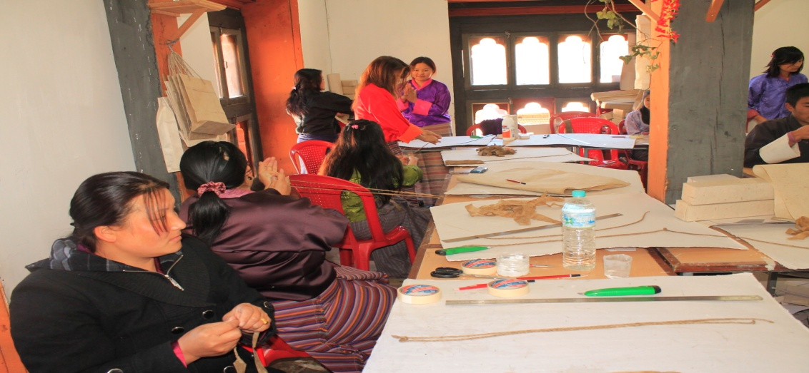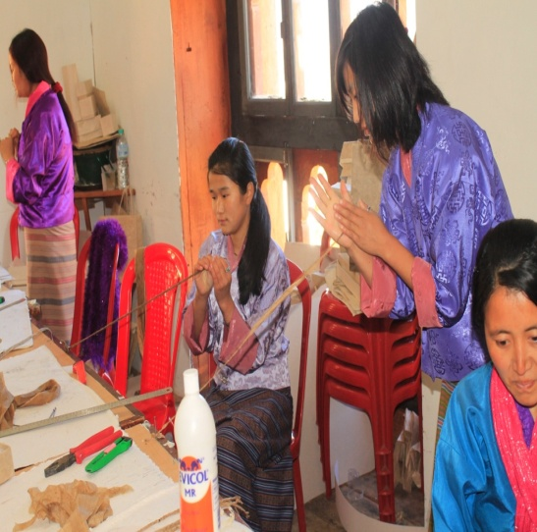

3. Participant’s List.

SL No. | Participant’s Name | Responsibility
1 | Ms. Kuenzang Dema | Participant
2 | Ms. Pema Yangzom (Stall 36) | Participant
3 | Ms. Pema Yangzom (Stall 47) | Participant
4 | Ms. Dorji Lhadon | Participant
5 | Ms. Tshering Pem | Participant
6 | Ms. Chimi Om | Participant
7 | Ms. Chenda Gyem | Participant
8 | Ms. Nima Zam | Participant
9 | Ms. Namgay Dema | Participant
10 | Ms. Chenga Lhamo | Participant
11 | Ms. Dawa Zangmo | Participant
12 | Ms. Dawa Dem | Participant
13 | Ms. Yeshi Pelden | Participant
14 | Mr. Pelden Wangchuk | Participant
15 | Mr. Tshering Dorji | Participant
16 | Mr. Chencho | Participant
17 | Mr. Dawchu | Participant
18 | Mr. Sangay Phuntsho | Participant
19 | Mr. Kuenga Dendup | Participant
20 | Mr.Dorji Wangchuk (A) | Participant
21 | Mr.Dorji Wangchuk (B) | Participant
22 | Mr. Penjor | Participant
23 | Mr. Dechen Dorji | Participant
24 | Mr. Karchung | Participant
25 | Mr. Sonam Wangdi | Participant
26 | Mr. Pema Thiney | Participant
27 | Mr. Tenzin Nima | Participant

4. Training Program

Day 1: Program started with the welcome speech by Lam Kezang Chhoephel, CEO, APIC, conveying the reason for conducting such workshop followed by the theoretical session by the two instructors. They explained on the needs and requirements of raw materials for this workshop. The participants were also briefed on effective training and continuity in producing their own packaging items after this training program. Beside this, Lam Kezang Chhoephel also urged participants to spread their skills and ideas to other interested craft dealers and shopkeepers in future.
For effective training, the two resource person has demonstrated on basic making of paper packaging and designs.

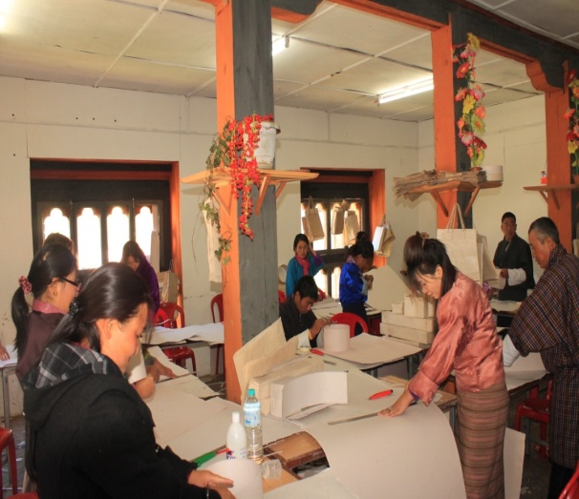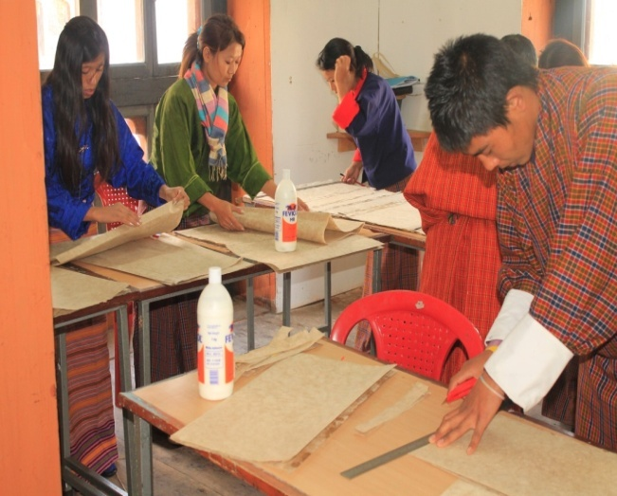

Day 2-8: Participants started practical based training. They were taught how to cut papers, design shapes and gluing on required sides. Each day was a new learning experience for them. Their skills improved and got more ideas in designing packaging bags and boxes. Some participants even started coming up with their own ideas and designs depending on the craft items that captures in their mind. By the end of day 8, we could witness the shapes were designed better, the techniques of designs were improved and time consumption has also been reduced. The time that they use to spend on day 1 has been reduced to half of it on day 8 for producing one packaging item. This reflects their interest in this workshop and effectives of this training program. Within these 8 days, the participants could make and design their own packaging materials with lesser guidance from our two trainers.

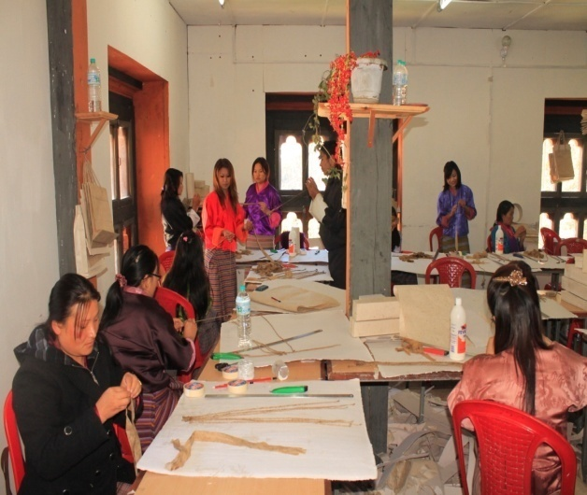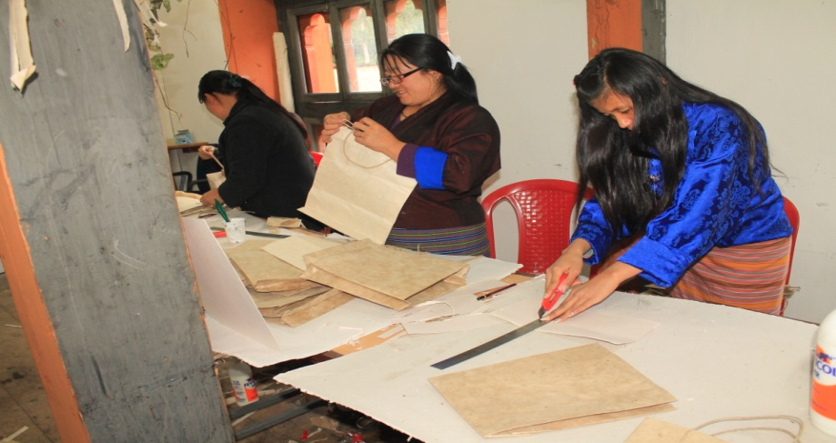

Day 9-10:
The last two days has been spent on the final touch on the packaging materials that they have made. Prefixing and sandwiching on materials produced by them was done on these two days. Beside this, the two instructors also educated our participants regarding fixing cost for the one packaging materials if they wish to sell it to other craft dealers. Finally, the two instructors debriefed and gave other relevant feedback required in paper packaging and designing.
At the end of this workshop, participants have made 105 different sizes of paper bags and 125 packaging boxes with different designs. In total they have made 250 plus packaging items with different sizes and designs.
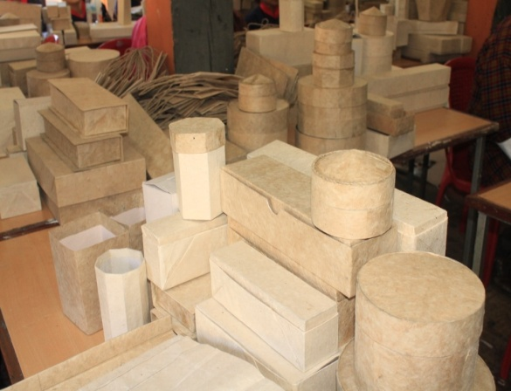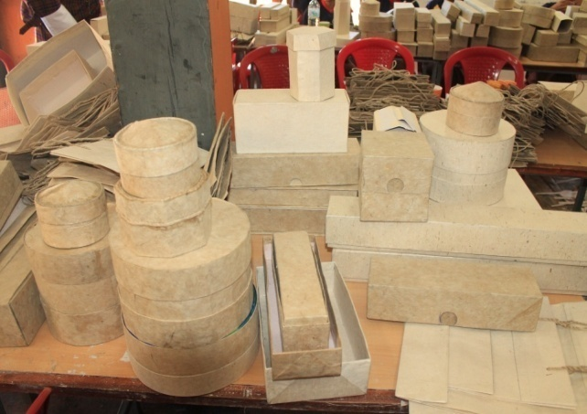
5. Conclusion:
As we all know, when we go to any shops in Bhutan, we either experience improper packaging or packaging materials that are being imported from India. This is due to lack of skills and ideas of our own crafts man and not looked after this draw backs. Therefore, this training has helped them in getting skills and ideas of making paper packaging and boxes with the guidance and instructions from our two expert trainers.
The training concluded with vote of thanks by Lam Kezang Chhoephel for being actively participating in this training program. He urged participants for continuous production of these packaging items which he said would be value addition to our handicrafts. He concluded by educating the participants that the skills acquired in this training workshop should be shared with other interested artisans for the benefit to improve consumer perception of our precious handicrafts.
