Training Workshop on Product Diversification for wood and metal works.
Introduction
As specified in the work plan for UN support for Development of MSME and employment Generation one of the targets set was for APIC as an implementing partner to conduct a workshop on product diversification which would result in production of at least 6 new wood and metal products and also at least 10 wood work and 10 metal work artists to be trained as Master crafts persons.
An eight day training was organized from the 20 th to the 27 of November in Kabisa the outskirts of Thimphu which is categorized as rural area as it is outside the city boundaries and we have found that it is an area where most young talented artists from rural areas choose to come and live in Kabisa as they can work closer to markets which is Thimphu in order to earn a decent livelihood.
The Objectives
The objectives of the training for both wood and metal work product diversification were first of all to produce at least 6 new products.
The second objective was to train artisans to think differently to emphasize on quality and products that can be sold both in the local market and to tourists.
The third objective was to train and try and achieve the goal of creating a number of master craftsperson’s using both modern machines and traditional tools and also to provide a platform for women and youth to be involved to resulting in self employment.
Participant List for Metal Product Diversification Training
Sl.No | Name of Artisans | CID No. | Address | Contact No.
1 | Sangay Chedup | 11312002362 | Sershong, Sarpang | 17290280
2 | Dema | 10101003751 | Thangbi, Bumthang | 17662814
3 | Karma Choden | 11505004922 | Khaling, Trashigang | 17603837
4 | Chador Wangmo | 11501000457 | Bartsham, Trashigang | 17721591
5 | Sonam Zangmo |  | Chidungkhar, S/Jongkhar | 17296288
6 | Lham Pelzom | 11405000865 | Kawang, Thimphu | 17692132
7 | Zhungchuk | 11704000779 | Daba Nubi, Trongsa | 17687429
Resource Person
1 | Sonam Phuntsho | 11607002233 | Trashiyangtse | 77999257
2 | Kinzang | 11605000175 | Trashiyangtse | 17723913
3 | Karma | 11601001433 | Trashiyangtse | 17657010

Sl.No | Name of Artisans | CID No. | Address | Contact No.
1 | Kinley | 10203001408 | Gedu, Chhukha | 17899385
2 | Rinchen Wangdi | 11312002360 | Sershong, Sarpang | 77307109
3 | Sonam Norbu | 11505004814 | Khaling, Trashigang | 16908332
4 | Nima Dorji | 10203003201 | Bongo, Chhukha | 17394382
5 | Tshering Tenzin | 11505003774 | Khaling, Trashigang | 17934865
6 | Thinley Phuntsho | 11006000315 | Khaling, Trashigang | 17942852
7 | Kinley Tshering | 10606002147 | Minjay, Lhuntse | 17759600
8 | Choki Dorji |  | Kurtoe, Lhuntse | 17295277
9 | Tashi Norbu | 11605000172 | Toedtsho, Trashiyangtse | 17677994
10 | Dechen Dorji | 10605002260 | Tangmachu, Lhuntse | 17934964
11 | Chencho Dorji | 11902000713 | Rukubji, Wangdue | 17504102
12 | Chador Wangdi | 12004001194 | Dakphai, Zhemgang | 17924942
Resource Person
1 | Sangay Penjor | 10702000598 | Mongar | 17726255
Participant List for Wood Product Diversification Training

Training Program
The first day of the training at Kabisa was started at two locations at Kabisa one for metal work and one area for wood work training. There was an introduction on the first day of the resource persons and what was to be achieved at the end of the programme including a registration of all the participants.
The trainees started from 9 to 5 every day for eight days the trainees were provided with raw materials and tools and machines to be used as part of the training. The trainees were also provided their meals as working lunches.

Metal Work
The first day of the metal work after introductions and registration was getting the trainees familiar with the tools and the work shop and the different tools used. We hoped to get experienced artisans so as to produce master crafts persons but in the metal work we faced a challenge to having to train the trainees from the basics.
The second day of training was more fruit full with the trainees who were mostly women and youth learning the basics and started working on small pieces of metal.
The third and fourth day was spent on refining the new trainee’s skills.
The last 4 days were spent in designing and creating new products with a lot of helps from the resource persons. 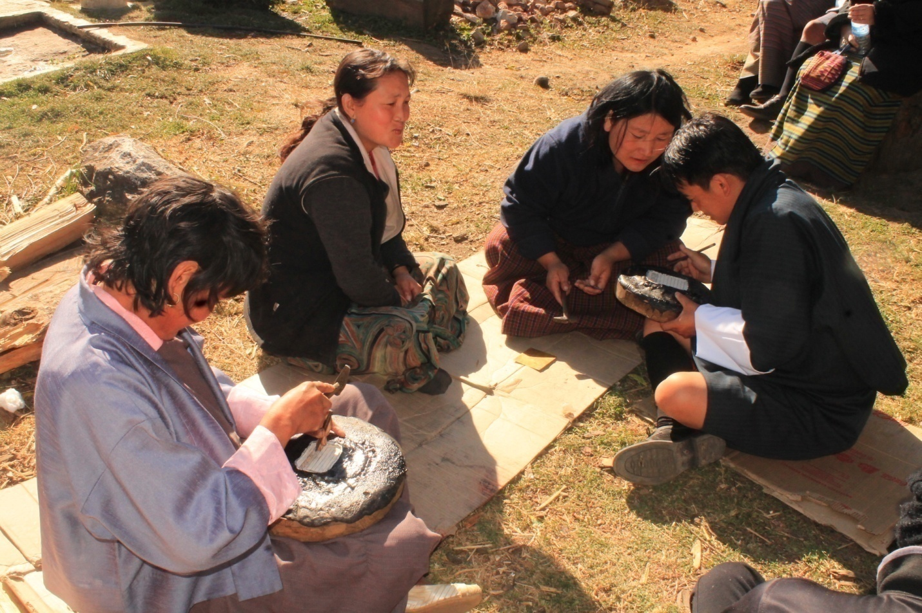

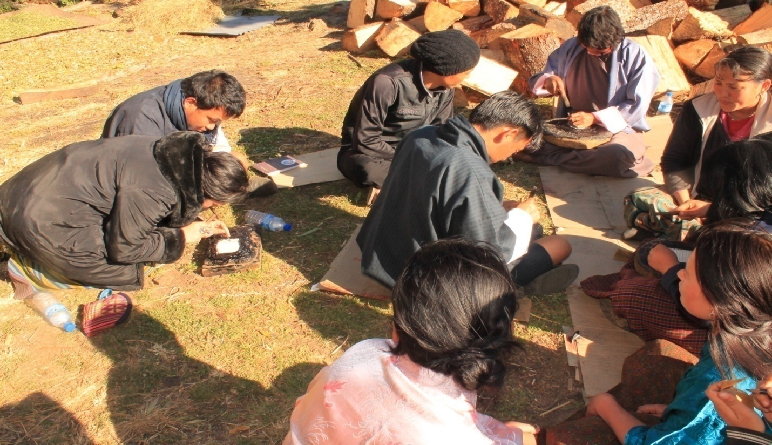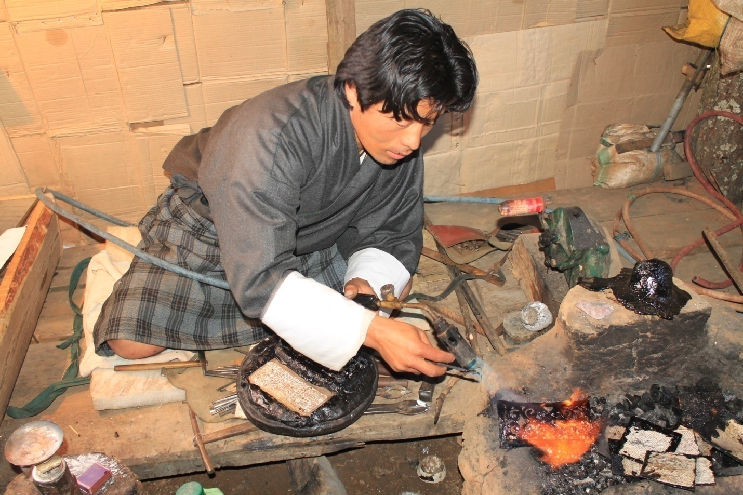

The number of products produced was a total of 22 pieces were created some are just basic inscribed copper.
Product diversification new designs
As a result of this training workshop six( 6) new products were created ,a tea light candle holder, bracelets with a new design ,a neck lace ,a chain and a table in order to use the work of the new artisans and a new version of Ra- dhung used in the Punakha Dromchoe( festival).
1. The tea light candle holder has Bhutanese metal work flower motif on it the design can be changed and the pattern crafted may be replaced with other motifs. The design is an item that would sell well with both locals and also tourists. It takes care of the cultural aspect in the form of the Bhutanese motifs but it is a product that has a not very traditional use but would sell well.
2. The bracelets are much bigger than traditional ones but have Bhutanese design aspects in the craft work and metal work design, this product is designed keeping in mind that a lot of young Bhutanese are influenced with fashion and this would be fashionable but also help conserve the traditional design and the indigenous methods of working with metal.
3. The necklace is the work of the new artisans and it is an effort to use work that may not be extremely refined but is still beautiful and sellable so that the new craftsperson’s can also sell products with a bit of innovation.
4. The chain is designed keeping in mind that thick chains are in fashion and double knotting and a simple technique can create something new out of an old technique.
5. The coffee table with metal plates attached is a product that can be easily crafted by learners and new craftsperson’s it is an attempt to use their skills and produce something Bhutanese but with a new way of using the crafted metal.
6. The last product is one of the most important designs produced; it is a Ra-dhung that has been redesigning an old Ra-dhung that is in use from the 4th temporal ruler (Desi) time. The shape and segment of the Ra-dhung were maintained as its original, but modified in decorative belts and valves added in outlook that promotes our cultural instruments with improvised skills.
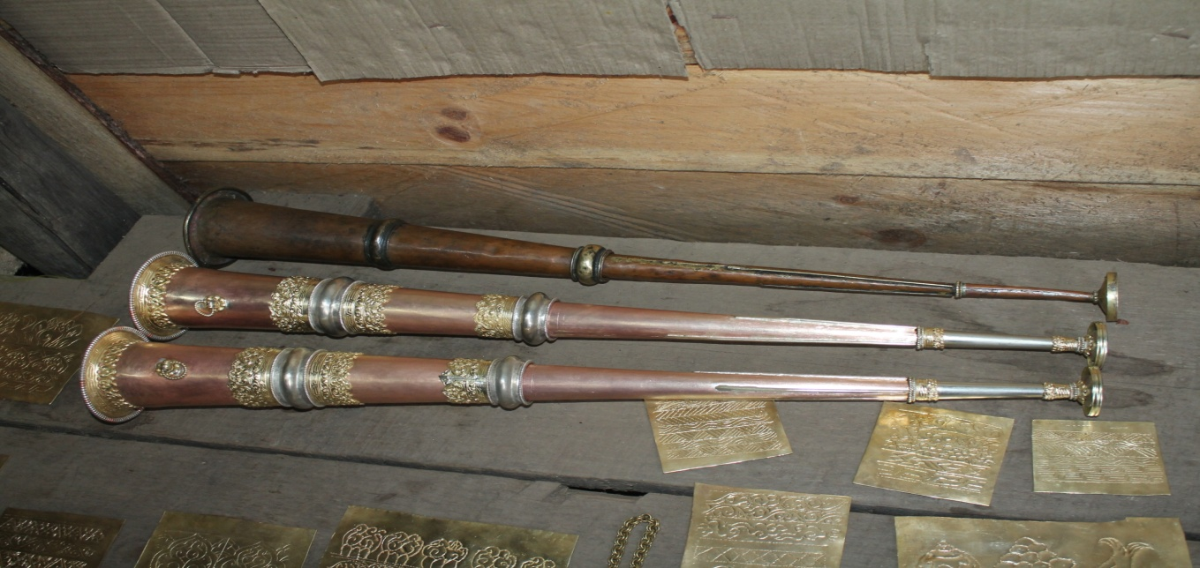

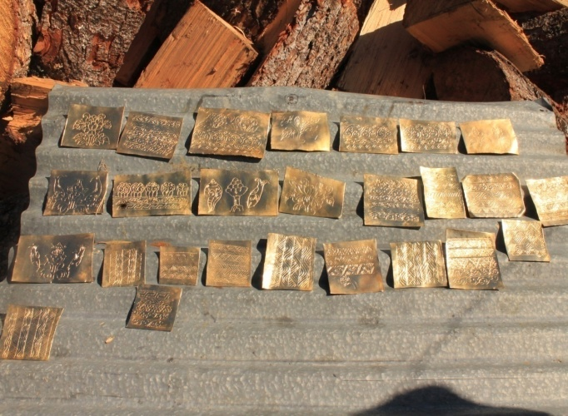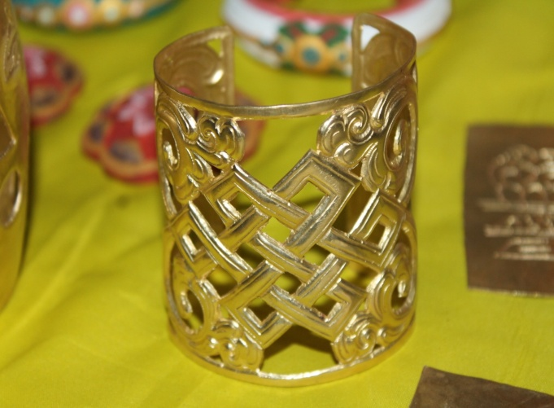
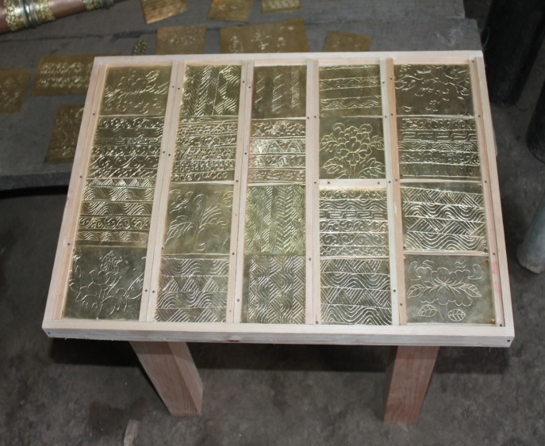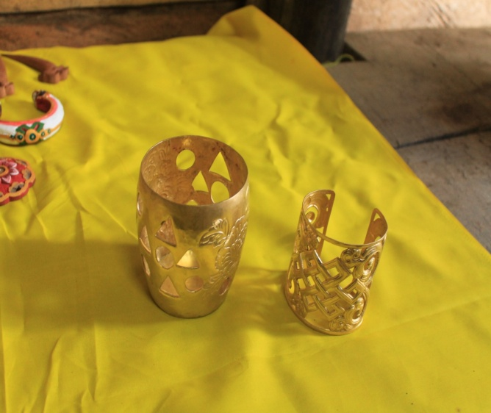

Wood work
The wood work program after registration as there was a mix of youth with both skills and persons with no basic skills the first day was an introduction to the tools and the processes involved.
The second day was an introduction to the basics of using different machines and traditional tools.
The third to the seventh day was a hands-on training in production of the new products.
The final day was for Finishing and painting the products. A total of 46 souvenir pieces were carved including the practice pieces.
Product Diversification
Six new designs were created out of these training workshops which include, new wooden bracelets, carved earrings, tea coaster, a little frame, and a carved table lamp.
1. The wooden bracelet designed keeping in mind the product has to be light and portable and convenient to wear and not very expensive. It preserves culture in the sense that traditional design from other metal work bracelets that exist as a part of our culture and tradition is the base idea the only innovation is that a different material wood and indigenous carving method is used. It also incorporates the art of Bhutanese mineral painting.

2. The wooden carved earrings are designed with traditional motifs and painting and is targeted as a product that can be sold to both young Bhutanese women and tourists.

4. The tea coasters are very easy for beginners to make and are light and convenient to transport and they are painted with Bhutanese motifs. it is a very simple item that can be produced in big quantities in a short span of time that will help turn over and help an artesian earn a livelihood with even little skill.

5.The little frames are portable ,light and a little piece of the wood crafting art that exists in our country this can be made by beginners and the costing is not very high and would be an appealing small product.

6.The last new product is a table lamp that is carved on all four sides this is a high end product that requires a lot of skill so it can be produced by master crafts persons but a simpler more basic one can probable be done by beginners. The table lamp is a great home accessory that is very Bhutanese with a new use.
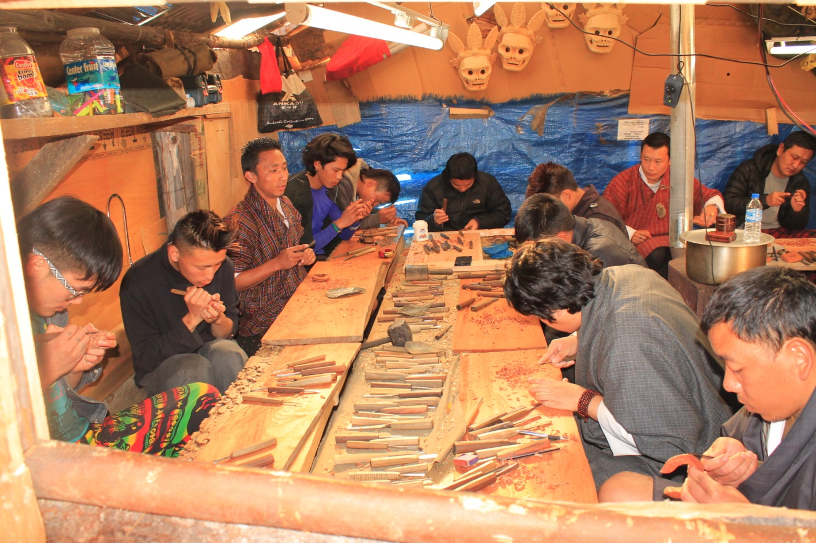

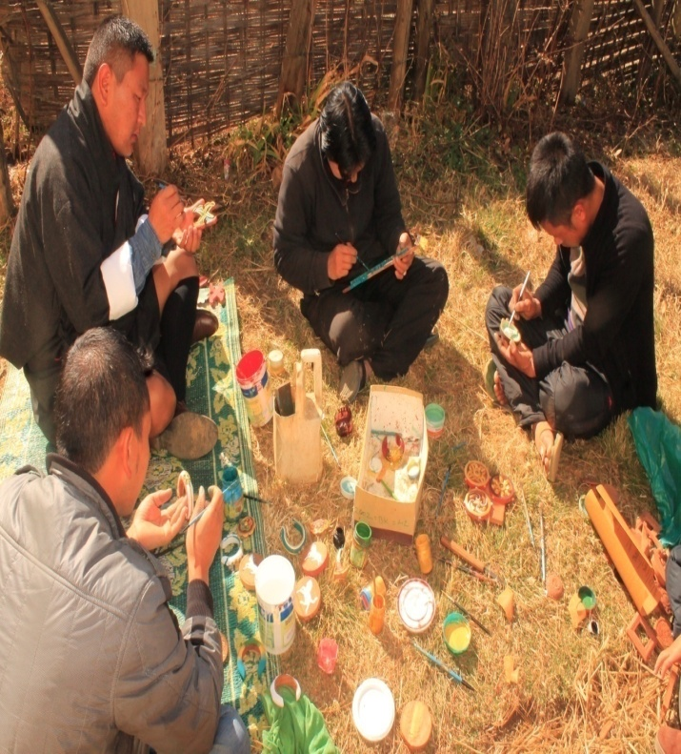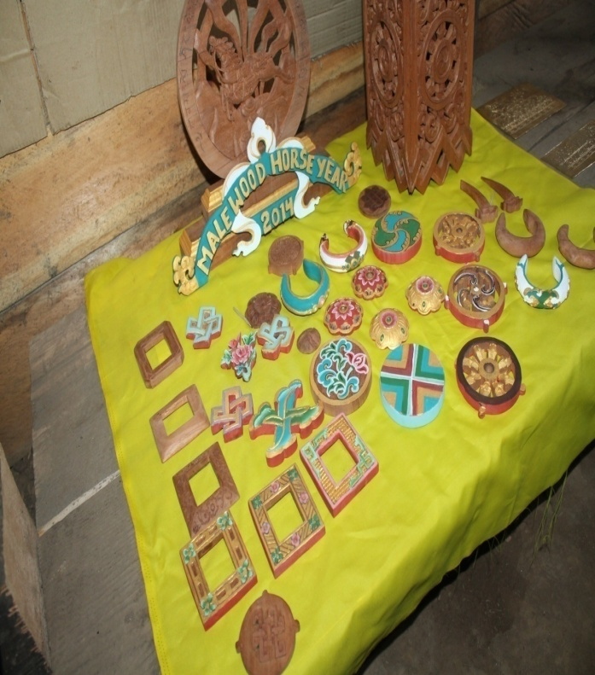

Conclusion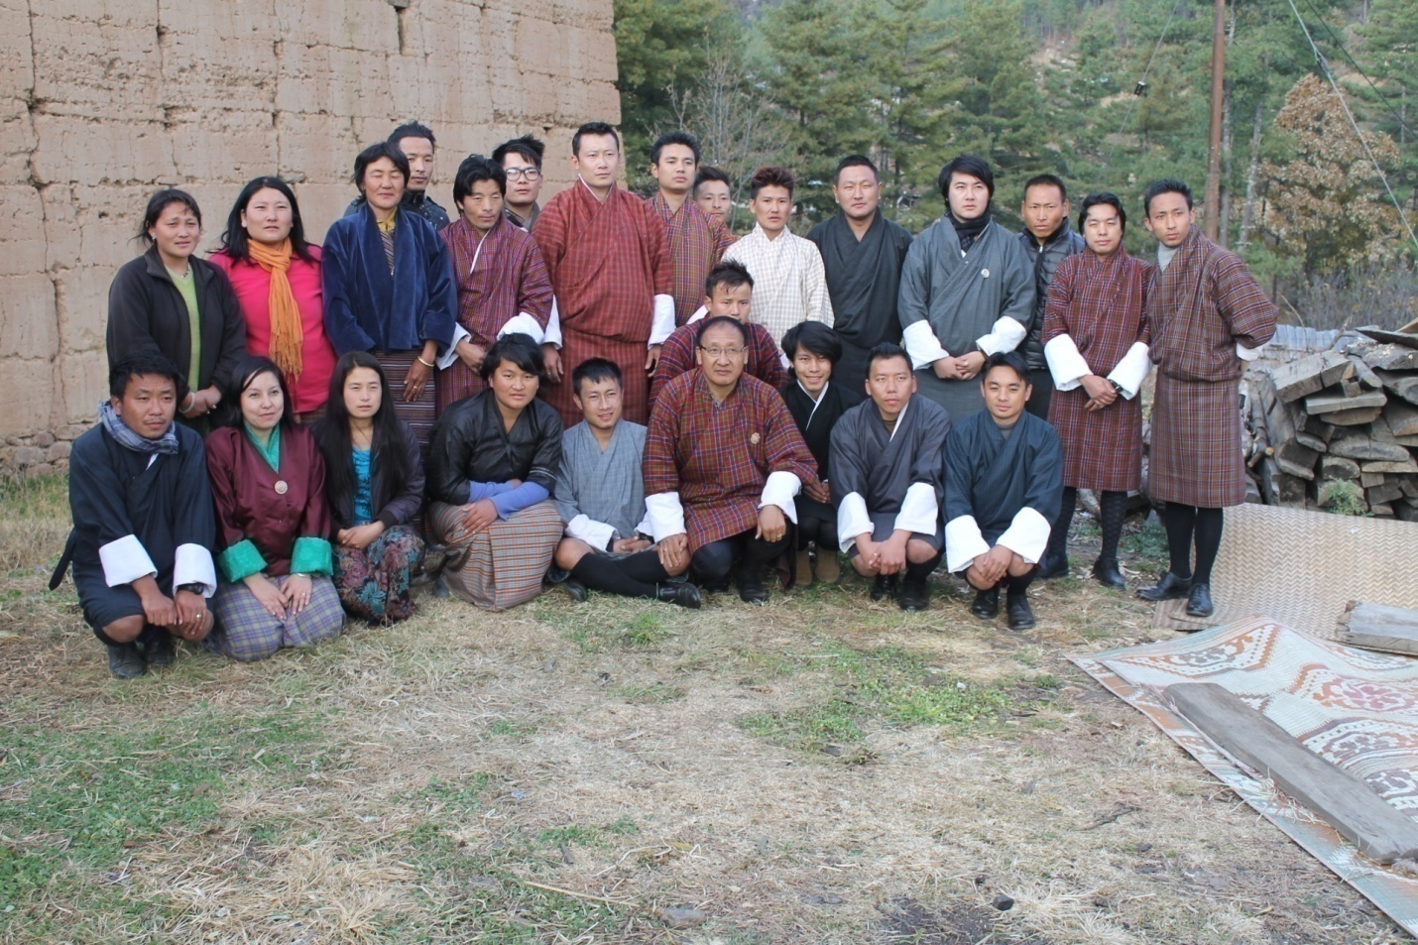 The training concluded with a small exhibition of the products for the trainees and the Chief Executive Officer of APIC. The CEO informed the participants that he saw great potential in them and he hoped that the skills acquired would be utilized and even a little skill if used properly could have great results. The CEO also said that he was happy to see interest of some educated youth in this program .The training concluded with the information that the certificates to the trainees will be awarded at a later date with an exhibition of the products from the various trainings held by the agency of promotion of indigenous crafts as a implementing agency with the help of the UN support.

